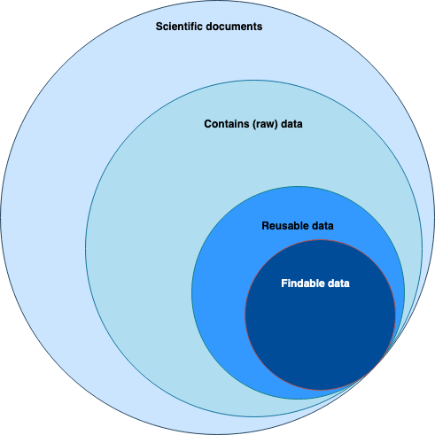

**Figure 1: The general situation of data sharing in Indonesia**

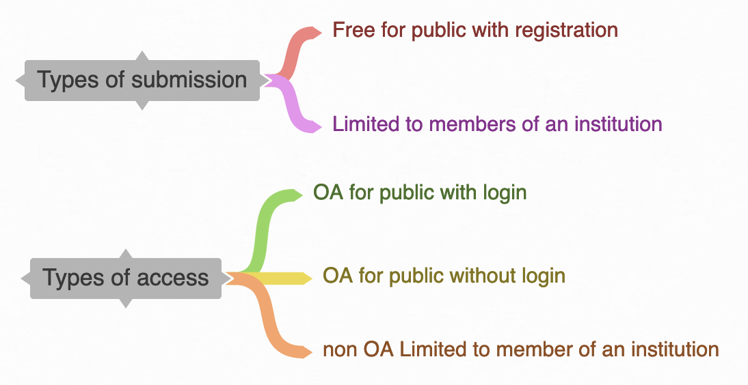

**Figure 2: The categories of earth science/geoscience repositories based on submission and access**

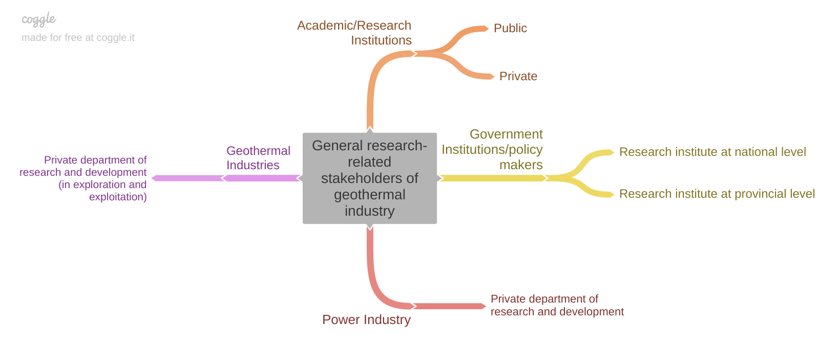

**Figure 3: The general stakeholders of geothermal industry**

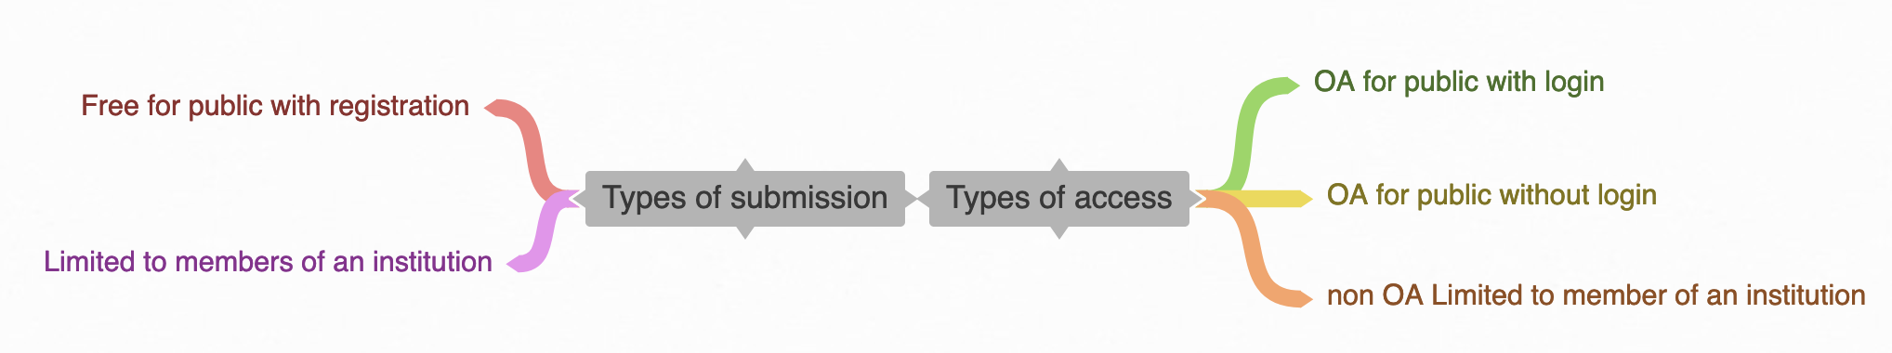

**Figure 4: The types of submission and access of data repositories**

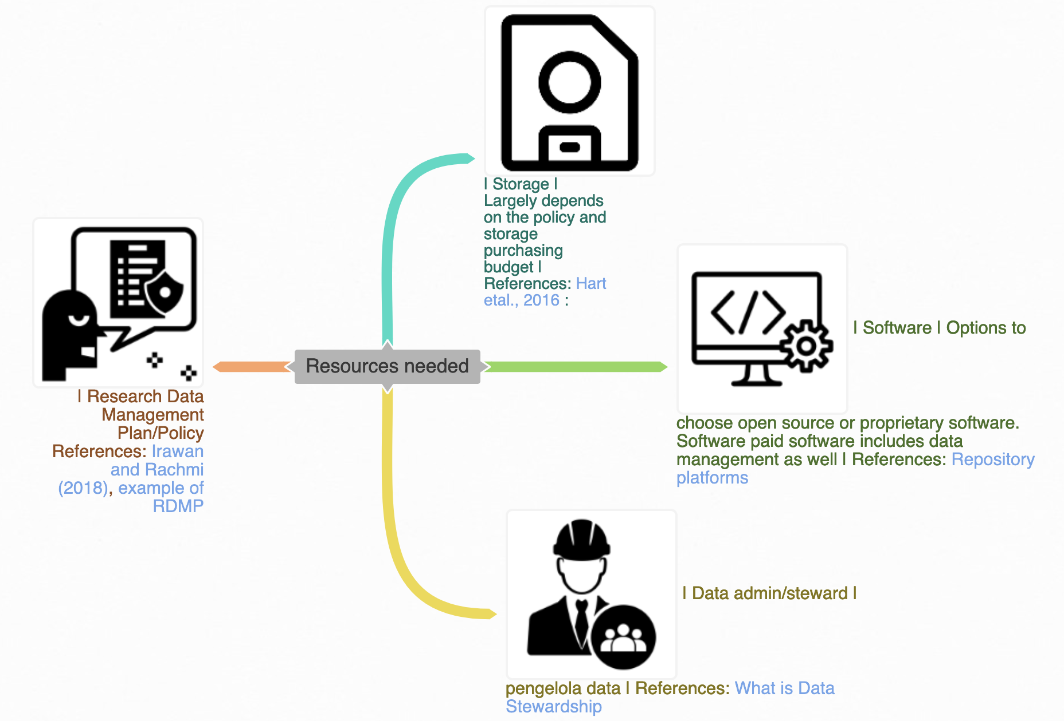

**Figure 5: Resources need in creating a data repository**

# 