A bibliometric study on the usage of isotope in hydrogeological studies in Indonesia
Dasapta Erwin Irawan^{1*}, Yuniarti Ulfa¹, Rusmawan Suwarman¹, Edi Riawan¹, Irwan Iskandar², Thomas Triadi Putranto³, Hari Siswoyo⁴, and Vinca Pascalia¹
¹ Faculty of Earth Science and Technology, Institut Teknologi Bandung, Indonesia
² Faculty of Mining and Petroleum Engineering, Institut Teknologi Bandung, Indonesia
³ Faculty of Engineering, Universitas Diponegoro, Indonesia
⁴ Faculty of Engineering, Universitas Brawijaya, Indonesia
* Correspondence:
Dasapta Erwin Irawan
r-win@office.itb.ac.id
Keywords: isotope₁, hydrogeology₂, environmental₃, bibliometric₄, Indonesia₅. (Min.5-Max. 8)
Abstract
Background: Hydrogeology education has been inserted into undergraduate geology education. In fact, since the early 1990s, postgraduate programs in Indonesia have been established specifically to study hydrogeology and its applications. We conducted a bibliometric review to identify advances in hydrogeological research using isotopes.
Methods: A total of 68 research articles using isotopes in various regions in Indonesia were extracted from the Scopus database. The corpus data were analyzed statistically with Orange Data Mining and bibliometrically with Vosviewer. We analyzed the relationship of authorship and keyword text mining to identify research groups, research funding flows, and the intensity of research collaboration that has occurred.
Conclusion: We found that although most of the research funding comes from the Government of Indonesia, there are many foreign research funders who fund research in Indonesia. This should be an indicator that the geology of Indonesia attracts interests from international researchers. Isotopes have been widely used for tectonics and volcanological studies and less for environmental studies. This is a sign of opportunities to solve environmental problems using isotopes. Various countries from Asia, Europe, America and Africa have collaborated with Indonesian researchers using various types of isotopes. Hydrogeological and environmental isotope research itself is still minimal. This may be related to mainstream focus on the mitigation of natural disasters and the exploitation of natural resources.

Introduction
Although a formal tertiary education in hydrogeology was started in Institut Teknologi Bandung (ITB) back in the early 1990s, it’s noted that one of the first field excursions in 1920 was to observe groundwater well in Bandung¹. Since 1993, there have been more than 200 graduates from the graduate program in hydrogeology. Since 2007, all options in hydrogeology or groundwater studies in ITB have been merged to form the Master Program of Hydrogeology.
In this paper we explore the state of hydrogeological research using isotopes in Indonesia, based on the available scholarly documents using major database and open source tools.

Materials and Methods
We used Scopus scientific databases for this study. Scopus is a commercial database owned by Elsevier, which covers 77 million documents in 2017². The database has been widely used as standard of research quality by Indonesia³. Scopus lists scientific documents in the form of articles, proceedings, reviews etc that are mainly written in English. The access to Scopus was provided by Institut Teknologi Bandung.
We analyzed the corpus using:
- Orange Data Mining⁴, a Python-based open source statistical package created by Bioinformatics Lab at University of Ljubljana, Slovenia, and
- Vosviewer, an open source bibliometric visualization app from CTNW Leiden. We used the software to extract the main research themes. The Vosviewer feature used is co-authorship and text mining visualization. Procedures are displayed as Powerpoint slides and uploaded in the data repository (link).

Results and Discussions
We analyze the main research themes related to the use of isotopes. Hydrogeological research using isotopes increased sharply in the 1990s (Figure 1). It is estimated that this is related to the flow of Indonesian researchers who completed their education abroad, especially in France and Germany.
Another cause is the increasing intensity of research and higher education funding, both through national funds through the Ministry of Research and Higher Education (currently divided into two ministries: the Ministry of Education and Culture and the National Research and Innovation Agency of the Republic of Indonesia) as well as grants from foreign institutions.
Most research funders are from Indonesia, especially from the Ministry of Education and Culture and several major universities such as the Bandung Institute of Technology, Padjadjaran University and the University of Indonesia, and several state research institutions such as BATAN and LIPI. The majority of research in Indonesia is funded by the government. Other research funding comes from Japan through the Japanese Ministry of Education, universities such as Kumamoto University, and associations such as the Japan Society for the Promotion of Science (Figure 2).
The research collaboration here is described through authorship at author, organization, and country level, and text mining on keywords. We used Vosviewer for visualizations.
The authors come from 20 countries from six continents. This reflects the collaboration that occurs among researchers. Researchers from Indonesia still dominate, followed by Japan, the United States, and European countries. Researchers from China are ranked 8th. The least is cooperation with researchers from Africa. This situation shows that cooperation among Asian countries is more and more strengthened. Collaboration with countries on the African continent is also starting to appear (Figure 3a and Figure 3b).

Of the 261 authors (Figure 4a and 4b) coming from 197 institutions (Figure 5a), only 51 coming from eight research institutions have strong relationships (Figure 5b). Those eight institutions are based in Japan and Indonesia. Figure 6 presents most collaborations by country.
Although isotope technology has developed rapidly, research on water, climate, and life sciences using isotopes in Indonesia is still far behind compared to research on tectonics, volcanology, and geophysics in general. More research funding flows for research themes of physics and chemistry than research on water and life sciences. This could be because research on water, climate, and life sciences requires a longer period of observation and development.
Figure 4a below shows the dominance of research on tectonic and volcanology conducted by several research groups. It is described in more detail in Figure 4b. Research on hydrology, including groundwater, surface water, climate and life sciences, is lagging behind. However, it should be realized that the Scopus database is exclusive, not all works especially those written in non-English languages are listed in it.
From 68 articles, 847 keywords were extracted from the title, abstract, and keywords. We picked up the keywords used in three or more different articles. There are 90 keywords, which are classified into four clusters. Each cluster describes a research theme (Figure 7).
We got four themes, each in blue, yellow, red, and green (clockwise). The blue theme is research related to paleoclimate, organic matter, carbon, and biogeochemistry. The yellow theme includes research related to tectonics, plate movement, petrology, and geochemistry. Research on volcanology, petrology, and petrography are highlighted in red. Then the green color contains research on geothermal, environment, groundwater, and surface water. This result is in line with the researchers' focus on the previous images.
- Conclusions
From this bibliometric study, research on groundwater or the fields of hydrogeology and environmental science in general is still not outstanding, when compared to other fields of science. It could be that the focus of research funders is to fund research directly related to geological natural disasters and mapping of mineral reserves⁵. Research on tectonics and volcanology will be closely related to the prediction of earthquakes and volcanic eruptions, which are research priorities in many countries.
Research on water and the environment also needs to get a sufficient portion of attention, considering that various current disasters are also closely related to the quantity and quality of water, such as floods and water pollution. Water accessibility which has been declared as one of the Sustainable Development Goals is one of the targets that need to be considered together for the benefit of the people.
The flow of research funds from foreign institutions to solve natural problems in Indonesia needs to be maintained so that it does not become "helicopter research" which places Indonesian researchers only on paper or does not involve them at all⁶⁷⁸. The current nature of research that highlights Diversity, Equity, and Inclusivity (DEI) is expected to make collaboration more fluid and benefit all stakeholders involved⁹¹⁰.
The current environmental isotope measurement technique has been very advanced and needs to be supported by the provision of evenly distributed test equipment, not only in universities located on the three main islands (Sumatra, Java and Bali) only. This will make isotope testing faster, more precise, and less expensive.

References
            - "Technische Hoogeschool te Bandoeng - Wikipedia bahasa ...." https://id.wikipedia.org/wiki/Technische_Hoogeschool_te_Bandoeng. Accessed 12 Jun. 2021.
            - "Scopus Tip & Trick: Search smarter, find faster | Elsevier Scopus Blog." https://blog.scopus.com/posts/scopus-tip-trick-search-smarter-find-faster. Accessed 12 Jun. 2021.
            - "Panduan Program Insentif Peningkatan Kualitas Jurnal Ilmiah 2020." 1 Oct. 2020, https://risbang.ristekbrin.go.id/wp-content/uploads/2020/10/Panduan-Program-Insentif-Peningkatan-Kualitas-Jurnal-Ilmiah-2020.pdf. Accessed 12 Jun. 2021.
            - "Orange: Data Mining Toolbox in Python - Journal of Machine ...." https://jmlr.org/papers/volume14/demsar13a/demsar13a.pdf. Accessed 23 Jun. 2021.
            - "Frontiers in Earth Science | Geohazards and Georisks." 25 Jun. 2021, https://www.frontiersin.org/journals/earth-science/sections/geohazards-and-georisks. Accessed 28 Jun. 2021.
            - "'Helicopter research': who benefits from international studies in ...." 29 Aug. 2018, https://theconversation.com/helicopter-research-who-benefits-from-international-studies-in-indonesia-102165. Accessed 28 Jun. 2021.
            - "HELICOPTER RESEARCH." https://irb.cherokee.org/media/rkknqeww/helicopter-research.pdf. Accessed 28 Jun. 2021.
            - "Global soil science research collaboration in the 21st century: Time ...." 15 Aug. 2020, https://www.sciencedirect.com/science/article/pii/S0016706120305036. Accessed 28 Jun. 2021.
            - "Uniting to Advance Diversity, Equity, and Inclusion in a Pandemic ...." 29 Jan. 2021, https://osf.io/preprints/d6z72/. Accessed 28 Jun. 2021.
            - "Diversity, Equity, and Inclusion in the Earth and Environmental ...." https://serc.carleton.edu/integrate/workshops/twp_support_students/index.html. Accessed 28 Jun. 2021.
            - "Content Policy and Selection - Content - Scopus - Solutions | Elsevier." https://www.elsevier.com/solutions/scopus/how-scopus-works/content/content-policy-and-selection. Accessed 12 Jun. 2021.

Tables and figures
Table 1 Search strategies
Databases | Links | Search strategies | Inclusion criteria | Object | Results | Search dates
Scopus | Scopus.com | In title “isotope” AND in title “Indonesia” | Yes¹¹ | To search for articles written in English | 68 | March 8th updated on June 5th 2021

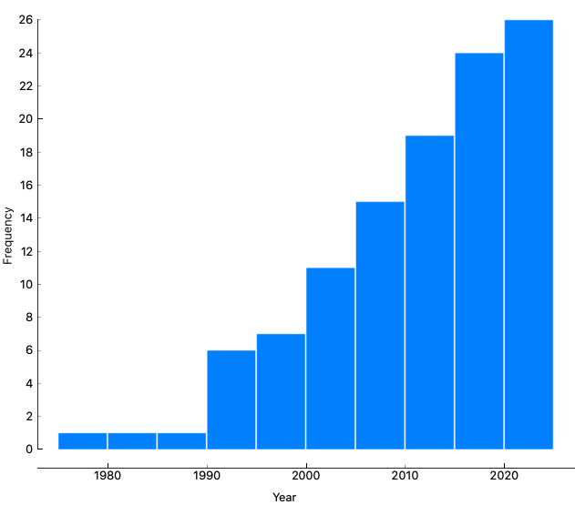
Figure 1 Distribution of published paper by year

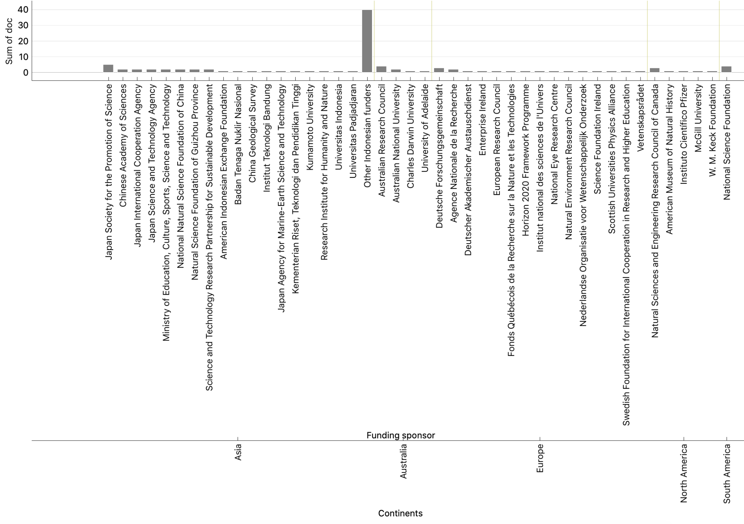
Figure 2 Distribution of research funders based on continents

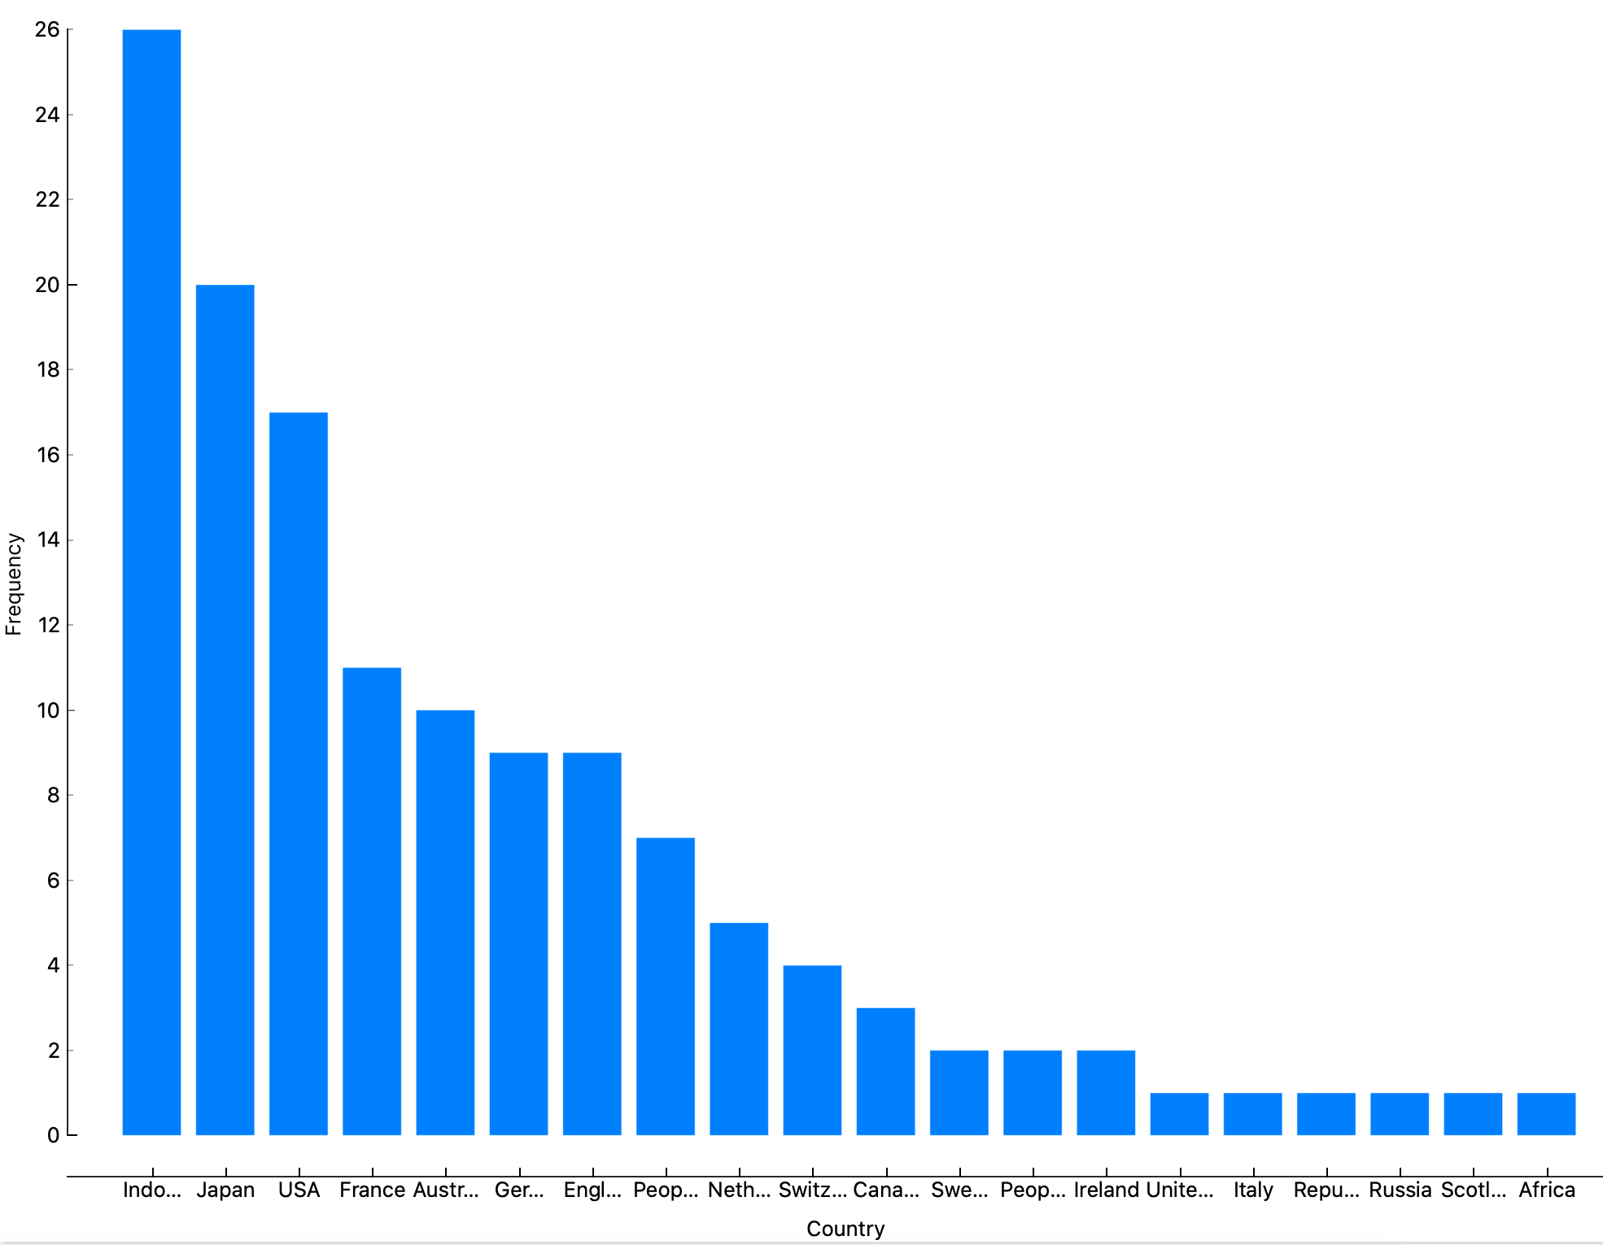
Figure 3a Distribution of authors based on countries

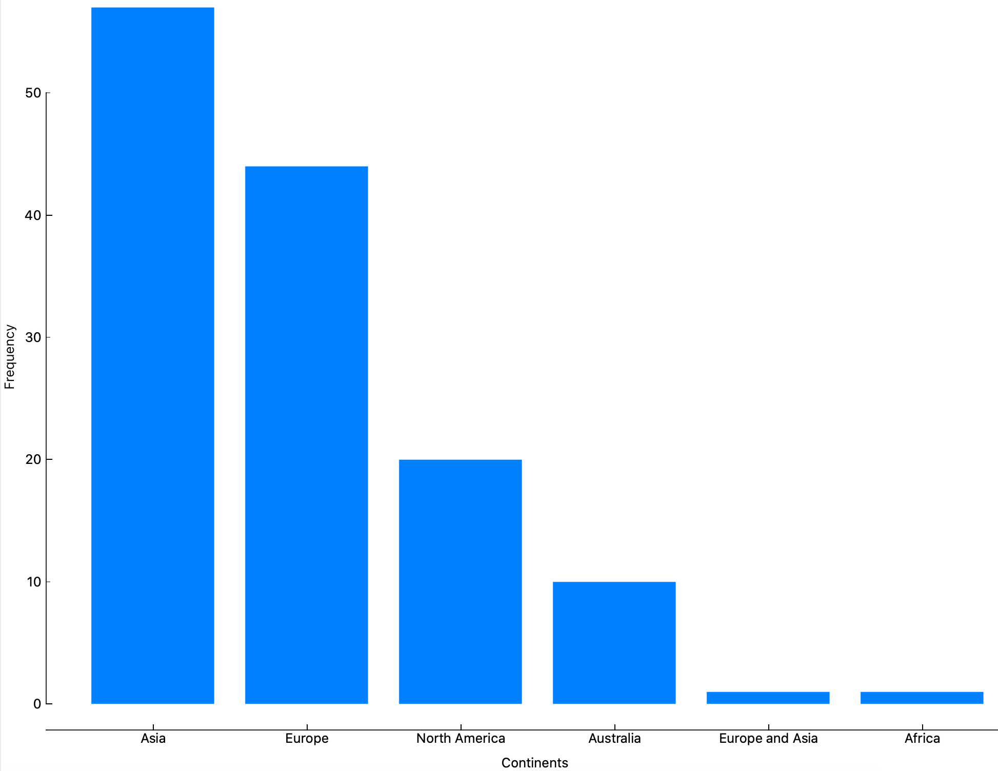
Figure 3b Distribution of authors based on continents
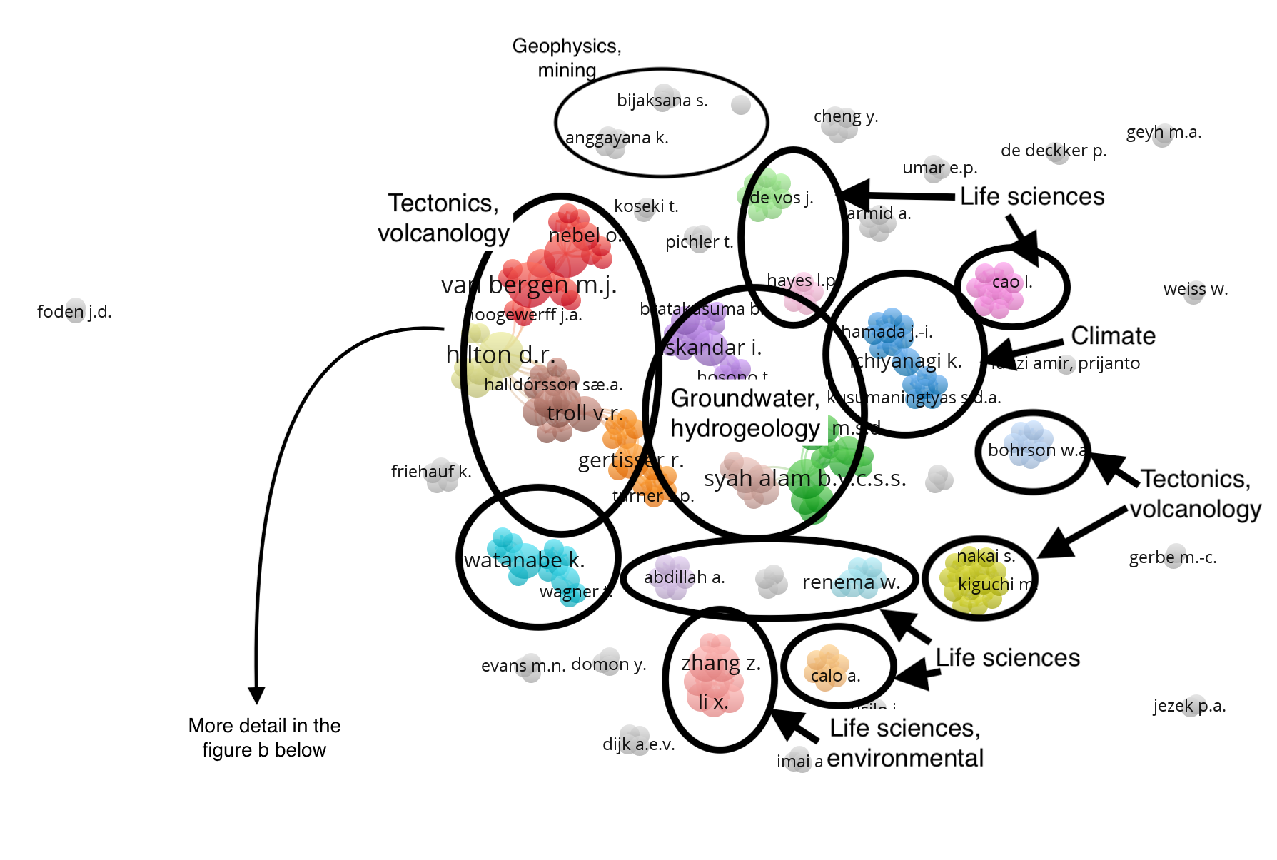
Figure 4a Co-authorship based on researchers

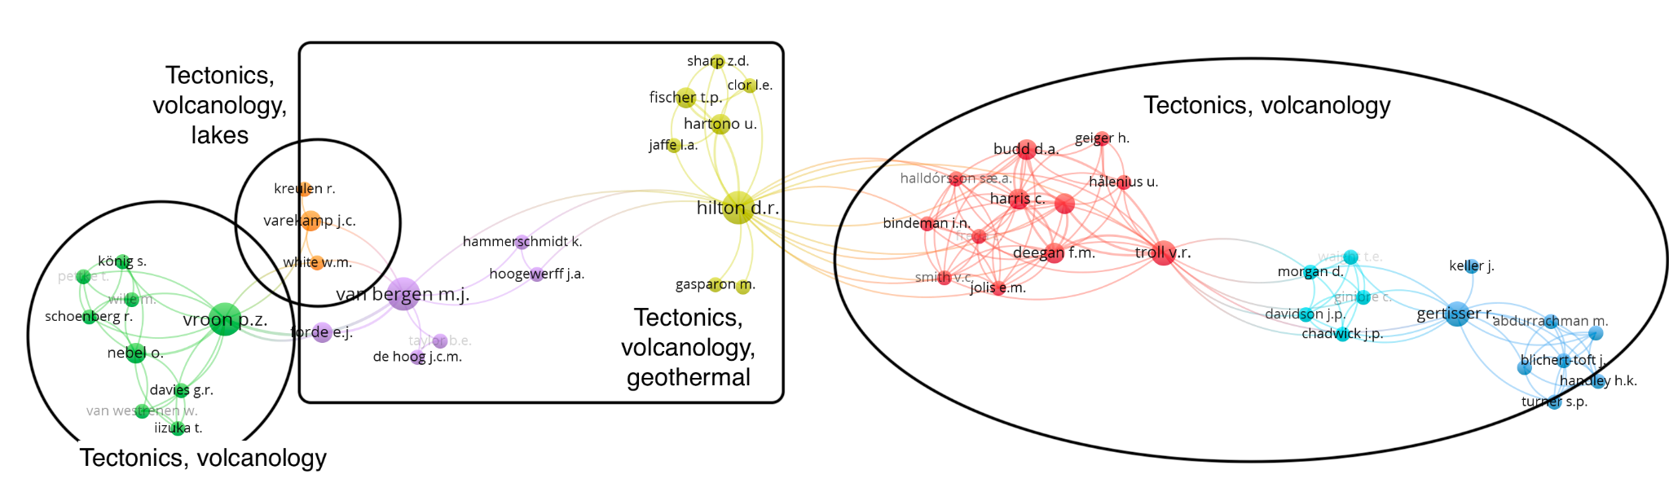
Figure 4b The strongest co-authorship based on researchers

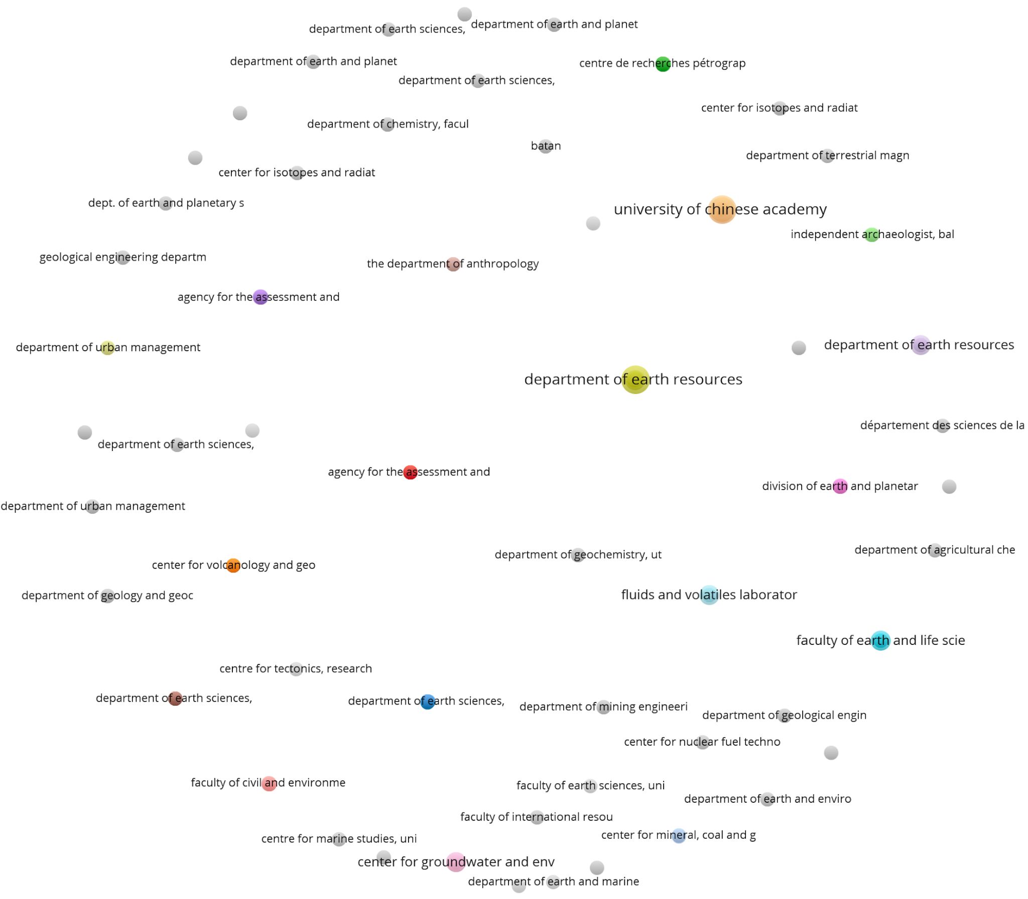
Figure 5a Co-authorship based on research organizations (affiliations)

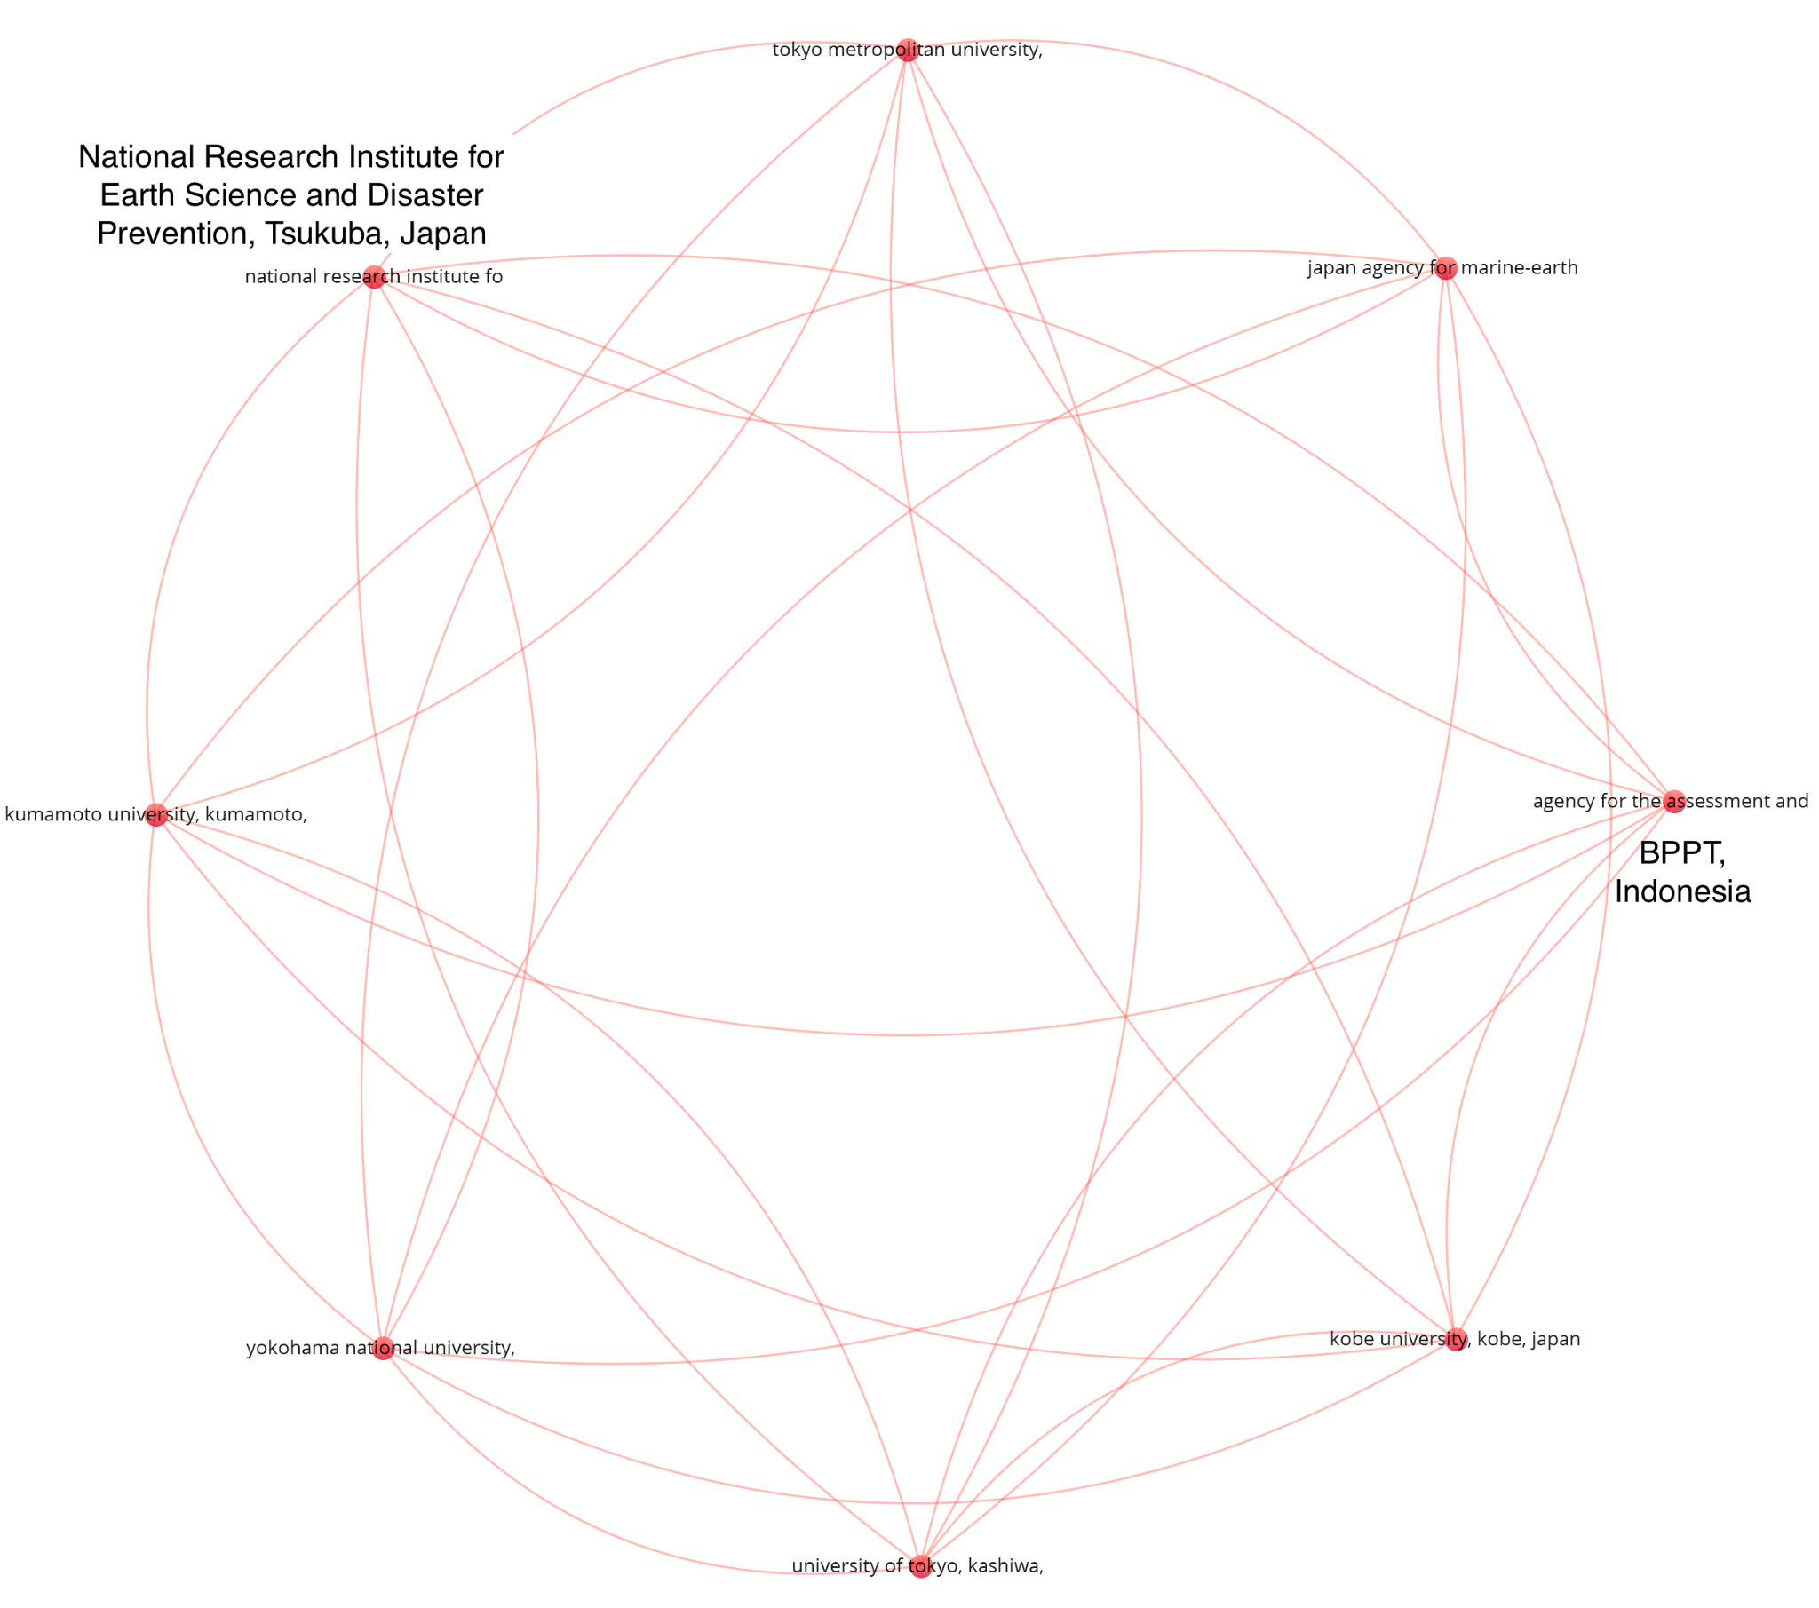
Figure 5b Co-authorship with the strongest collaboration based on research organizations (affiliations)

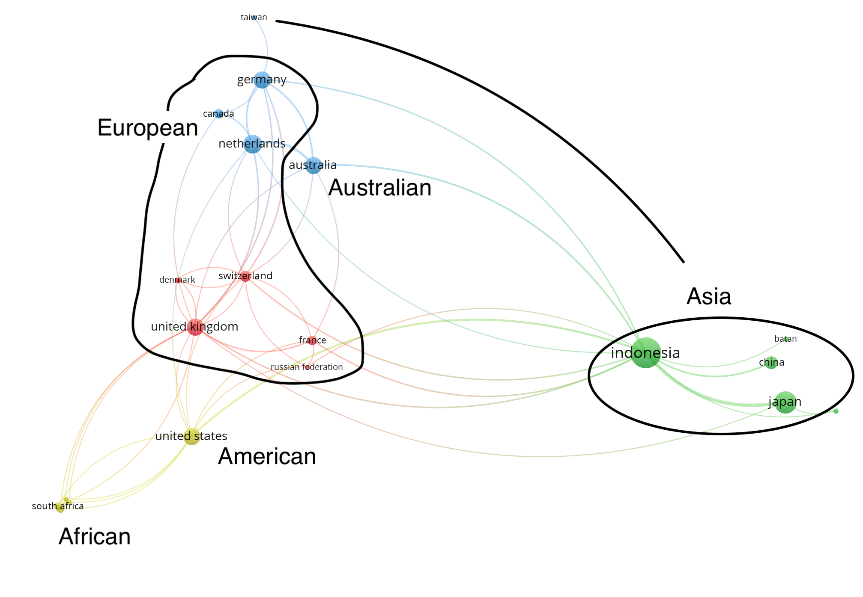
Figure 6 Co-authorship with the strongest collaboration based on nationality and continent

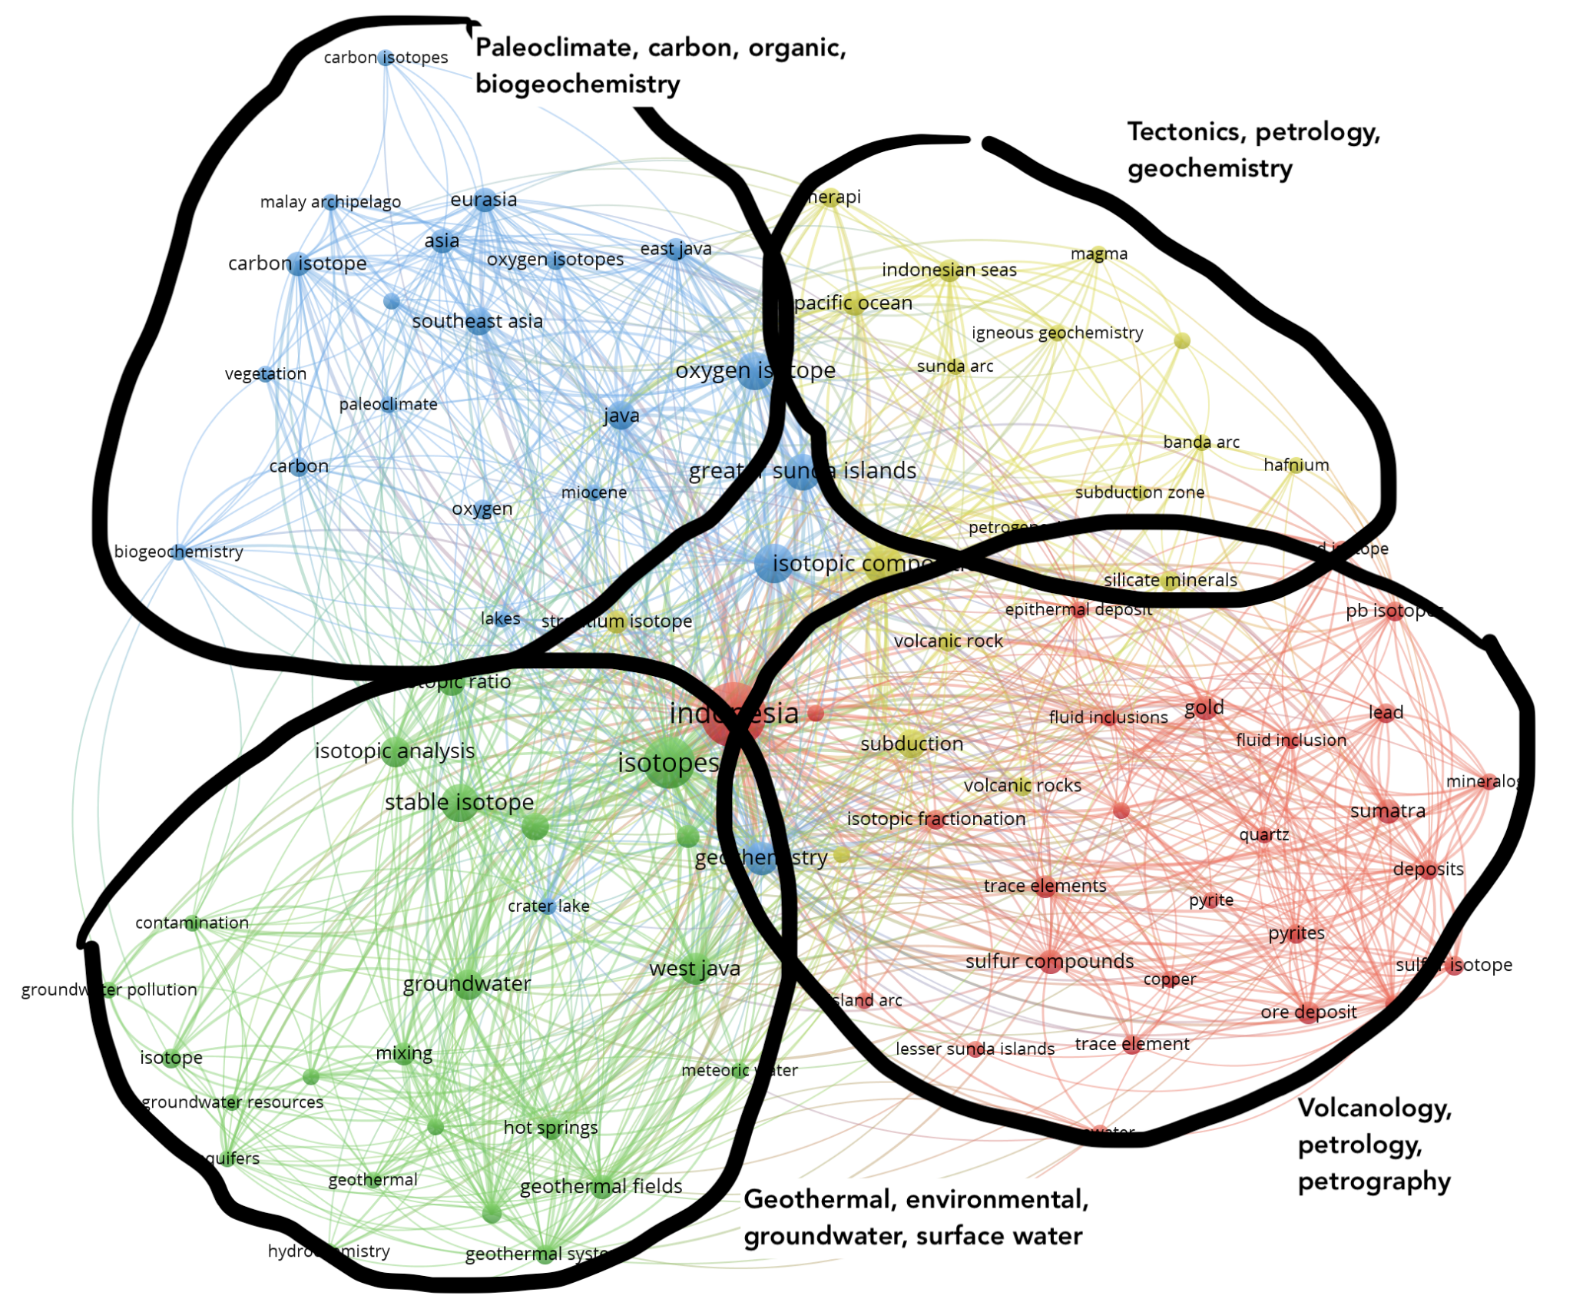
Figure 7 Research themes mapping based on keyword analysis

Conflict of Interest
The authors declare that the research was conducted in the absence of any commercial or financial relationships that could be construed as a potential conflict of interest.

Author Contributions
Dasapta Erwin Irawan: conceive the ideas, data collecting, drafting the manuscript
Yunuarti Ulfa: data collecting, drafting the manuscript
Rusmawan Suwarman: drafting the manuscript
Edy Riawan; drafting the manuscript
Irwan Iskandar: drafting the manuscript
Thomas Triadi Putranto: drafting the manuscript
Hari Siswoyo: drafting the manuscript
Vinca Pascalia: data cleaning, drafting the manuscript

Funding
This research was funded by Institut Teknologi Bandung under the P2MI Grant Fiscal Year 2021.

Acknowledgments
We thank the feedback from Prof. Hutasoit dan Prof. Puradimaja from Applied Geology Research Group, and The Dean of Faculty of Earth Sciences and Technology, Institut Teknologi Bandung.

Data Availability Statement
The datasets GENERATED AND ANALYZED for this study can be found in the FIGSHARE REPOSITORY. DOI: https://doi.org/10.6084/m9.figshare.14864895.v3.

