**Software Development using Machine Learning to Predict PPFG and 3D Geomechanics**

*Pipit Irfani Amorokhman1, Allen Haryanto Lukmana2, Pertamina Research Technology Innovation1 UPN Veteran Yogyakarta2*

**Abstract**

Pressure prediction plays a fundamental role to design mud weight and well trajectory for wellbore stability and prevents stuck pipe. Some manual calculations are only able to calculate on certain conditions such as clean-shale formation and under-compaction mechanism formation. Unfortunately, the real formation can be very heterogenic. A method to produce an independent formation type shall be developed solve the issue. Therefore, software using machine learning (ML) was developed to generate scrupulous pressure prediction.

The fold system is dominated by the WNW-ESE trending anticlinoria. Generally forming an en-echelon pattern explanation:

- Wrench movement along the NW-SE basement faults (related to the Paleogene graben system) (Harding,1988) .

-Draping over uplifted blocks due to compressive regime of the subduction (Moulds, 1989).

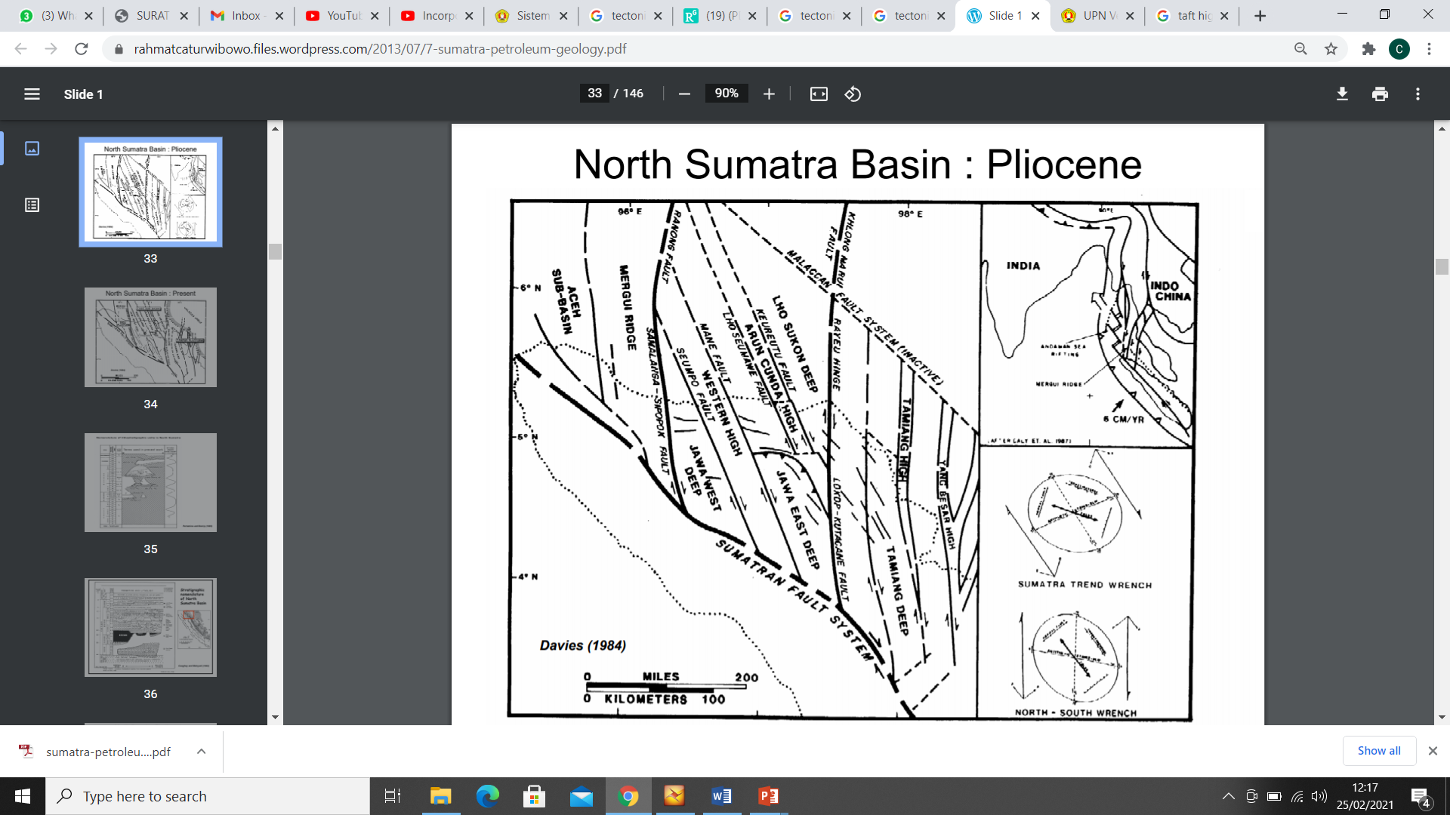

Figure 1. North Sumatera Basin where MLC-001 and TTA-001 Location

The Present Stress was dominantly from Plio-Pleistocene Stress. Well MLC-1 dan TTA-1 are under U-S pattern with stress direction NE-SW (N 020 E – N 060 E) & (N 200 E – N 240 E).

Logging data (e.g., Density, Sonic, Gamma Ray) and drilling parameter (e.g., ROP, RPM, WOB) from 2 wells (MLC-01, TTA-01) were used as machines learning input. In this research, 3 methods which are Artificial Neural Network (ANN) Feedforward type, Random Forest (RF), and Support Vector Machine (SVM) were applied.

The result exhibits (1) ANN showed the least Root Square Mean Error (RSME) of 0.11401 in comparison to the other 3 methods, Determination Coefficient (R2) 0.9789. Thus, ANN will be used for the rest of the analysis. (2) 4 data (Density, Sonic, Gamma Ray, Depth) together achieve the most precise with actual condition with RSME 0.0714 and R2 0.9826. (3) After plotting the result in one graph, pore pressure prediction from ANN method is closer to actual pore pressure rather than manual calculation result.

It is to conclude that this software gives a promising result to predict Pore Pressure, Fracture Gradient, and Shear Failure Gradient. The comparative analysis results show that ANN Feedforward type has the feature estimation by its shorter time prediction and high accuracy (a coefficient of determination of 0.99 and RSME 0.08 – 0.23. The overpressure prediction, XRD, and Geomechanics can be analyzed in one integrated software.

**Introduction**

Basic geomechanical components are include pore pressure (PP), unconfined compression strength (UCS), Overburden or Vertical stress (Sv), Minimum horizontal stress (Shmin), and maximum horizontal stress (SHmax). These component gained from core measurement. However, core measurement cannot be performed in the whole interval regarding core limitation. Prediction calculation can be alternative, but it require many data and only specific condition to use the method

Pore pressure at depth is equivalent to hydraulic potential measurement from earth surface. Assumed to be uniform in a small volume of interconnected pores. Therefore, pore pressure can be variated refer to geological events. Overpressure occurs as several factors such as Disequilibrium compaction, tectonic compaction, hydrocarbon column height, Aqua-thermal compaction, mineral diagenesis, and hydrocarbon maturation.

.

Artificial Intelligence (AI) and Machine Learning (ML) have grown their popularity among many industries. It supported by development of technology in computer service makes big data acquisition is easier than before. However, energy sector is still left behind.

In this paper we rise a case study using data from 2 exploration wells located in North Sumatera. Depth of well reached 9000 ft, TTA-01 and MLC-01. Overpressure occurred for both of wells during drilling activity. The Team developing a software using AI and ML to predict PP froman existing log and drilling data. The result of AI prediction will be compared to manual calculations and recorded data.

**Data and Method**

**Geological and Stratigraphical Setting**

**Log and Drilling Data**Data from well TTA-01 will be input as learning data, consist of RHOB, DTCO, GR, ECD, RPM, WOB, ROP, and recorded pore pressure. The final model will be used to predict pore pressure for well MLC-001



Figure 2. Drilling Parameter of Welll TTA-01

**Method:**

**Artificial Neural Network (ANN)**

ANN is a method which is inspired by “neuron” system in human brain. It is using connectivity between “neuron” to find the right model. The target can be iterations limit or maximum error value determine by researchers.

𝑦 = 𝑎𝑥 + 𝑏𝑦 + 𝑐𝑧 + … … . . + 𝑚𝑛

𝑎, 𝑏, 𝑐, …, 𝑚 is input variable

𝑥, 𝑦, 𝑧, …, 𝑛 is training weight

**Analysis Steps:**

**Preprocessing**

The data cleaning process required raw data preprocessing. Then it will be divided into 2 types of data input, training and testing.

* Data 1: in this process, all of data output (Pore Pressure) smaller than 0 (negative) will be deleted.
* Data 2: in this process, all of data output (Pore Pressure) smaller than 0 (negative) will be converted 0.

**Testing   
Machine Learning Method**

Testing process will determine the most suitable machine learning methods and final validation will use a 10-fold cross. The method with result R2 closest to 1, RSME closest to 0, and optimum training time.

Table 1. Accuracy of Machine Learning Methods

Based on table 1, ANN shows the best result with the lowest RMSE 0.11401 and R2 0.9644. ANN will be used as ML method in this research.

**Result and Discussion**

**Learning Rate**

Table 2. Determination of Optimum Learning Rate

We need to find the correct learning rate for well TTA-001. Normally, the smaller learning rate the smaller error rate will gain but the longer convergent time needed. So the optimum value should be obtained by trial and error.

Learning rate 0.01 shown as optimum value as RSME had reached 0.1121 and R2 0.978. The researcher tried to decrease the learning rate to 0.00025 as RSME and R2 improved insignificantly yet had increased learning time significantly.

**Error Threshold**

Error threshold is the limit of training process time. If error threshold reached its value, then the training will stop. If value of error threshold is too large the training will stop faster causing the optimal condition not being achieved (error percentage may still be high). However, if error threshold value is too small then training will last longer, and most likely stop because the maximum iteration has been reached before error threshold value is reached. In this paper, there was 4 error threshold values tested with the result below.

Table 3. Determination of Error Threshold

Error threshold 0.0001 cannot be reach because training process stopped first (500.000 iterations). Error threshold value 0.0005 result RSME 0.1104 and R2 0.9781. However, error threshold value 0.00025 give insignificant improved result but it took a longer training process time.

**Data Combination**

The quantity of neuron in hidden layer determine the complexity of ANN. The greater amount of neurons, the more complex and time consuming the process will be. There will be 4 data combinations as the input training parameters with a minimum 3 input variables. The result is combinations of depth, DTCO, GR, and RHOB got the lowest RMSE with R2 closest to 1.

Table 4. Determination of Optimal Data Combinations

**Comparison Between Machine Learning Result vs Calculation Result**

Figure 3. Comparison Between Manual Calculation and Predicted Pressure by Machine Learning

The picture shows that machine learning is having the same capacity to predict pore pressure as manual calculation. The input data used in this calculation is wireline log data.

**Conclusions**

# Artificial Neural Network (ANN) is the most suitable machine learning method with R2 0.9789, RSME 0.11401, 10-Fold RSME 0.1240, 10-Fold R2 0.9644.

# In this case study using learning rate 0.01, error threshold 0.1 as the optimum training variable.

# Machine learning is able to predict pressure with a more efficient and faster result compared to manual calculation.

**References**

Moulds, P.J 1989, Ann. Conv. Indonesia Petroleum Association (IPA), **18**, 217-245.

Wilcox, R.E., T.P. Harding & D.R. Seeley 1973. American Assoc. Petrol. Geol. (AAPG) Bull. 57, 74-96.