Open Access in Indonesia

Dasapta Erwin Irawan (ORCID)[1], Juneman Abraham (ORCID)[2], Rizqy Amelia Zein (ORCID)[3], Ilham Akhsanu Ridlo (ORCID)[4], Eric Kunto Aribowo (ORCID)[4]
[1] Applied Geology Research Group, Faculty of Earth Sciences and Technology, Institut Teknologi Bandung, Bandung, Indonesia, r-win@office.itb.ac.id
[2] Psychology Department, Faculty of Humanities, Bina Nusantara University, Jakarta, Indonesia, juneman@binus.ac.id
[3] Department of Personality and Social Psychology, Universitas Airlangga, Surabaya, Indonesia, amelia.zein@psikologi.unair.ac.id
[4] Department of Health Policy and Administration, Universitas Airlangga, Surabaya, Indonesia, ilham.ridlo@fkm.unair.ac.id
[5] Faculty of Teacher Training and Education, Universitas Widya Dharma, Klaten, Indonesia, eric.kunto.a@mail.ugm.ac.id

Abstract
Despite the absence of funding pressures that explicitly mandate a shift to Open Access, Indonesia is a leader in Open Access publication. Yet Indonesia subscribes to a non-profit model of Open Access, which differs from that promoted by Plan-S. The penetration of bibliometric systems of academic performance assessment is pushing Indonesian scholars away from local non-profit model of Open Access to a model based on high publication charges. This briefing considers whether Plan-S promotes or undermines the ability of Indonesian scholars to develop systems of Open Access adapted to local resource constraints and research needs.
Key words: open access, Indonesia, publishing system, research output

INTRODUCTION
Indonesia is a leading proponent of OA, ranking 2nd behind the United Kingdom for the number of Open Access journals listed in Directory of Open Access Journals (DOAJ) (Morrison, 2019; Van Noorden, 2019) and in 2020 it publishes the most open access journals in the world (Irawan et al., 2020). Many would be surprised to note that the publication of Open Access (OA) journals in countries of the Global South, such as Indonesia and Brazil, is significantly higher than many prominent OECD countries, such as the United States and Germany. A recent article in Nature claimed that ‘Indonesia may be the world’s OA leader’, observing that in 2017, 74% of articles published with an Indonesian-affiliated author were open access, compared to only 60% in the UK, and a global average of 41% (Pashaei and Morrison, 2019a; Van Noorden, 2019). However, most Indonesian journals are embedded in universities and rely on institutional funding, giving rise to an OA model that does not rely on article processing charges (APCs) or subscription fees (Copiello, 2020; THE, 2019). This is similar to the OA model in many other parts of the Global South, such as Latin America, representing a non-profit approach to OA that is more equitable and sustainable for resource-constrained low and middle-income countries.

While a free-to-publish OA culture is deeply embedded in the Indonesian research ecosystem (Irawan et al., 2018, 2020a), new institutional pressures by the Indonesian state are pushing Indonesian academics toward publishing in top journals (Matthias, 2018) where most of them directly or directly in favor of pay-to-publish OA models, especially those with progressively expensive APCs. New regulations governing academic quality assessment and promotions based on international bibliometric standards are driving Indonesian scholars to seek publication in high impact international journals, where high APCs threaten to draw public resources out of the underfunded Indonesian research system in the service of private profits for corporate publishers. This briefing examines whether the benefits of Open Access for Indonesian researchers are advanced or undermined by a shift toward for-profit OA models promoted by Plan-S.

Open Access and Research Quality
Most Indonesian journals are managed by universities, research institutes, and professional associations, and almost all are OA. Indonesia has 1,598 journals listed in the DOAJ, published in Arabic and Indonesian as well as in English (Houissa, 2020). A recent study shows that 75% of Indonesian journals do not charge any APC, and the remainders charge very low fees, yielding an average APC of $79 (Figure 1), compared to an average of over $1,500 in the US and UK, and over $1,000 in other Western European countries (Pashaei and Morrison, 2019b).

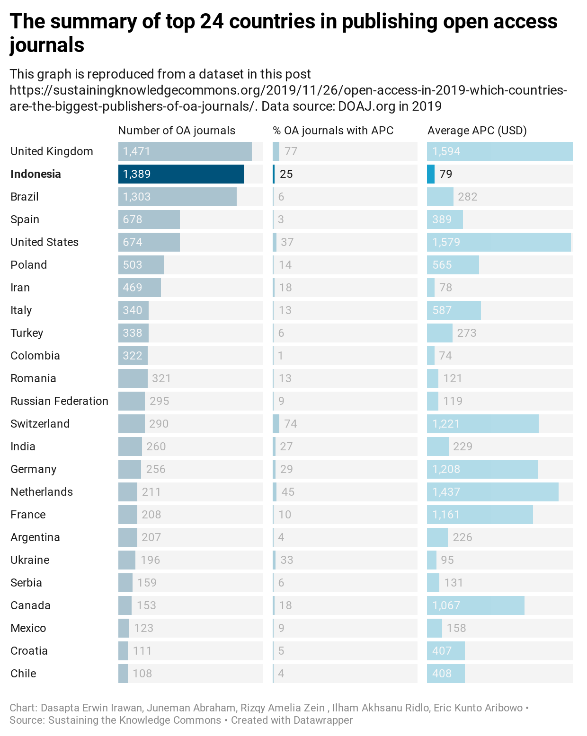
Figure 1 Top 24 Countries by Number of Open Access Journals and Average APC (2019) (Reproduced from Pashaei and Morrison, 2019b, link https://www.datawrapper.de/_/0ftyj/)

Despite a high number of Open Access journals and low or no APCs, Indonesia performs relatively poorly to neighboring ASEAN countries concerning publication in internationally indexed journals which in this context is publishing in top journals. As of 2017, the research performance of Indonesian scholars was ranked 57th in the SCImago index (Scimago Lab, 2020), below Malaysia and Thailand, ranked 35 and 43 respectively. Since 2016, the Indonesian government has implemented a range of new metric-based measures to improve the academic ranking and visibility of Indonesian scholarly output.

However, questions arise as to whose access to knowledge is improved by these measures. While Indonesian research is made more accessible to international scholars, pressures to engage with international OA publishing have had a less positive effect on research and publication opportunities for Indonesian scholars. Openness should not be for the sake of openness itself but might involve underlying values which guide the practice of openness. A closer look at variations in models of Open Access and how they interact with bibliometric quality assessment systems, raises important questions about whose entitlement Open Access is intended to promote.

Non-Profit and For-Profit Models of OA
While often discussed under a single term, Open Access involves different models which have varied effects on the distribution of costs and benefits (Irawan et al., 2018, 2020b). These can broadly be categorized as non-profit and for-profit models. A prominent example of the non-profit model is AmeliCA, based on a coalition of UNESCO with two Latin American-based scholarly organizations, which promotes a predominantly publicly funded tradition of Open Access (AmeliCA, 2020). Focused on the academic needs of the Global South, AmeliCA treats research as a common good, using digital platforms to promote non-profit open science, while emphasizing the importance of diversity rather than uniformity in publishing ecosystems (Poynder, 2019a, 2019b). AmeliCA favors what is referred to as ‘Diamond’ Open Access, which involves the use of public funding to make academic publications free to publish and free to access, similar to the dominant form of Open Access publishing prevalent in Indonesia.

Plan-S, an initiative of a consortium of 24 European research funders, is focused on driving a rapid transition to Open Access in European higher education and publishing, promoting a largely for-profit model (cOAlition S, 2020). Plan-S recognizes two main types of OA: Green OA, involving the deposit of free-to access versions of articles in institutional repositories, often with embargo periods; and Gold OA, which involves immediate, unrestricted access to published articles online, often associated with the payment of APCs. Efforts by Plan-S to transition rapidly to Gold OA have raised concerns about a tendency to favor the interests of commercial publishers over the needs of scholars in the Global South, given the high cost of APCs to publish in many international journals.

Reshaping OA Ecosystems in Indonesia
Recent changes in Indonesia’s academic quality assessment regime illustrate the tensions between the established local OA ecosystem and the new pressures generated by for-profit models of OA. Released in 2017, The Indonesian Ministry of Research, Technology and Higher Education introduced Science and Technology Index (SINTA) (Ditjen Penguatan Riset dan Pengembangan, 2019) accompanied with new regulations to expand the rules for academic promotion and quality assessment including the introduction of SINTA-based metric intended to improve Indonesia’s research performance (LLDikti Wilayah VIII, 2020). SINTA includes data from Scopus and Google Scholar publication indexes. Publication in ‘reputable’ journals became a requirement for academic promotion, accompanied by harsh sanctions for failure, such as terminating professional allowances that can constitute a significant proportion of lecturers’ pay (Tim BKD Ristekdikti, 2017).

Despite ample domestic OA journals in which to publish their work, Indonesian scholars are under pressure to publish in journals that appear in prestigious indexes, in pursuit of higher impact factor and citations to satisfy academic assessment criteria. Scopus and Web of Science are classified by the government as more reputable than Indonesian publication indexes (Irawan et al., 2018). Yet language barriers, as well as inadequate research funding and laboratory facilities make it difficult for many Indonesian scholars to gain access to highly ranked indexing platforms, such as Scopus, which does not index Indonesian-language journals (Sofyani et al., 2019). Scholars who succeed in publishing in highly ranked international journals draw constrained public research funding into financing the cost of high APCs. A recent study shows that average APCs in Indonesian language journals amount to $43, while average APCs in English language journals is $1,096 (Pashaei and Morrison, 2019b). As quality assessment criteria pressure Indonesian researchers to publish in higher ranking English language journals listed in prestigious indexes, a growing share of state resources flow into paying high APCs to commercial publishers, rather than into improving local academic research facilities and research funding to improve research quality from below.

Instead of strengthening OA practices in Indonesia, the focus on bibliometric performance assessment undermines the vibrant OA culture embedded in Indonesia’s research ecosystem, drawing research away from Indonesian OA journals, and public resources away from investment in improving research quality. In the process, attention is distracted from alternative approaches to strengthening Indonesia’s existing non-profit OA ecosystem. Indonesia already has a Law on the Openness of Public Information (Undang-Undang Nomor 14 Tahun 2008, 2008) and its derivatives, with One Data Initiative, Portal Satu Data Indonesia (Tim Satu Data Indonesia, 2020) as one of the initiatives that encourages open access to data held by government agencies, with wider importance for public accountability and local sensemaking of data.

There are also efforts to develop systems of Green OA in Indonesia. Building on existing practices of depositing dissertations and other research output in university repositories, the Centre for Data and Scientific Information (PDDI) at the National Institute of Science (LIPI) – Indonesia’s largest research institution – has launched a National Scientific Repository (RIN) to improve research transparency while strengthening free to publish forms of OA (Chuah and Loayza, 2017; Dzulfikar, 2019; PDDI LIPI, 2020) and a cloud server dedicated to host national OA journals using Open Journal System (OJS) from Public Knowledge Project (PKP) called Rujukan (Rumah Jurnal Keilmuan/The House of Scientific Journals) (Tim Rujukan, 2020). Rujukan server is now hosting 300 active scientific journals. A similar initiative has been started by Opscidia (Opscidia Team, 2019).

While concerns about copyright protection and misuse of shared data are still obstacles, addressing these is part of the process of developing locally accountable OA ecosystems (Tennant et al., 2019). Bibliometric indicators of international OA ecosystems are equally open to abuse, as recent instances of Indonesian scholars ‘gaming the system’ have shown (Rochmyaningsih, 2019), as it also boosts the number of conference proceeding papers as the easiest way to get indexed in Scopus (Purnell, 2020). OA is not inherently good or bad; rather, the social processes that accompany openness need to be created to facilitate the goal of constructive openness, suited to the needs of society.
While expecting a change in the current performance measurement system is perpetual, Dalimunthe (2020) and Indonesian Open Science Team came up with an idea to build an alternate small parallel system relying on content-based article assessment, exploration of diverse research topics, and eradicating the superiority of English as a universal academic language. A similar system like Redalyc (Redalyc, 2020) and Curate Science (Curate Science Team, 2020) with the participation from several largest public universities and private equivalent would be enough for the pilot testing. The funding would be sought from external and internal philanthropists before then funded by public funding after several evaluations.

CONCLUSION
Indonesia and other countries of the Global South are being reduced to followers of the Open Access policies emerging from the Global North. The globalization of research and higher education is driving the imposition of uniform indicators and criteria, rather than promoting diverse Open Access models adapted to local resource and research needs. With OA quality standards built on standardized metrics, Plan-S will only further strengthen the arguments linking quality with high APC costs faced by researchers and institutions. This runs contrary to the Indonesian Open Science Movement which prioritizes the independence of research, the promotion of knowledge as a common good rather than a source of corporate profit, and the use of public funding to strengthen the local research ecosystem.

Conflict of interest declaration
All authors state no conflict of interest upon the publication of this manuscript.

REFERENCES

AmeliCA (2020) ‘AmeliCA’. http://amelica.org/index.php/en/about
Chuah, L.L. and N. Loayza (2017) ‘Open Data: Differences and Implications across Countries’, The World Bank. https://econpapers.repec.org/paper/wbkwbkrpb/114829.htm
cOAlition S (2020) ‘“Plan S” and “COAlition S” – Accelerating the Transition to Full and Immediate Open Access to Scientific Publications’. https://www.coalition-s.org
Copiello, S. (2020) ‘Business as Usual with Article Processing Charges in the Transition towards OA Publishing: A Case Study based on Elsevier’, Publications 8(1): 3.
Curate Science Team (2020, November) ‘Transparent & Credible Evidence’. https://curatescience.org/app/home
Dalimunthe, S. (2020, November) ‘Funding Open Science Projects - Thoughts, Ideas, Experience, Bureaucracy’. IGDORE Forum. https://forum.igdore.org/t/funding-open-science-projects-thoughts-ideas-experience-bureaucracy/971/7
Ditjen Penguatan Riset dan Pengembangan (2019, February). ‘SINTA Talks 2019: Ristekdikti Buka Forum untuk Kritik SINTA Habis-habisan’. RistekBRIN. https://risbang.ristekbrin.go.id/publikasi/berita-kegiatan/sinta-talks-2019-ristekdikti-buka-forum-untuk-kritik-sinta-habis-habisan/
Dzulfikar, L.T. (2019, November) ‘Indonesia’s First Scientific Data Bank is a Step towards Strengthening “Open Data” Practices’. The Conversation. https://theconversation.com/indonesias-first-scientific-data-bank-is-a-step-towards-strengthening-open-data-practices-126632
Houissa, S. (2020, May) ‘What’s in a “NAME”? A Study of African and Arab Journals in the DOAJ’. DOAJ News Service. https://blog.doaj.org/2020/05/11/whats-in-a-name-a-study-of-african-and-arab-journals-in-the-doaj
Irawan, D.E. et al. (2018) ‘Era Baru Publikasi Di Indonesia: Status Jurnal Open Access di Directory of Open Access Journal (DOAJ)’, Berkala Ilmu Perpustakaan dan Informasi 14(2): 133–147.
Irawan, D.E., B. Priadi, L.T. Muharlisiani, S. Onie, and Z.D. Rusnalasari (2020a, October) ‘Indonesia Publishes the Most Open-Access Journals in the World: What It Means for Local Research’. The Conversation. https://theconversation.com/indonesia-publishes-the-most-open-access-journals-in-the-world-what-it-means-for-local-research-147421
Irawan, D.E., J. Abraham, R.A. Zein, and S. Gutam (2020b, November) ‘India’s Plan to Pay Journal Subscription Fees for All Its Citizen May End up Making Science Harder to Access’. The Conversation. https://theconversation.com/indias-plan-to-pay-journal-subscription-fees-for-all-its-citizen-may-end-up-making-science-harder-to-access-147444
LLDikti Wilayah VIII (2020) Surat Edaran Kepala LLDikti Wilayah VIII Pengusulan Jabatan Akademik Dosen. https://lldikti8.ristekdikti.go.id/2020/03/27/surat-edaran-kepala-lldikti-wilayah-viii-pengusulan-jabatan-akademik-dosen/
Matthias, L. (2018) ‘Open Science in Indonesia’. OpenAIRE. https://www.openaire.eu/blogs/open-science-in-indonesia
Morrison, H. (2019, November) ‘OA APC Longitudinal Survey 2019’. Sustaining the Knowledge Commons / Soutenir Les Savoirs Communs. https://sustainingknowledgecommons.org/2019/11/27/oa-apc-longitudinal-survey-2019
Pashaei, H. and H. Morrison (2019a, November) ‘DOAJ 2019: Language Analysis’. Sustaining the Knowledge Commons / Soutenir Les Savoirs Communs. https://sustainingknowledgecommons.org/2019/11/26/doaj-2019-language-analysis
Pashaei, H. and H. Morrison (2019b, November) ‘Open Access in 2019: Which Countries Are the Biggest Publishers of OA Journals?’. Sustaining the Knowledge Commons / Soutenir Les Savoirs Communs. https://sustainingknowledgecommons.org/2019/11/26/open-access-in-2019-which-countries-are-the-biggest-publishers-of-oa-journals
PDDI LIPI (2020) ‘RIN Data Repository’. http://rin.lipi.go.id
Poynder, R. (2019a, March) ‘Plan S and the Global South – What Do Countries in the Global South Stand to Gain from Signing up to Europe’s Open Access Strategy?’. Impact of Social Sciences. https://blogs.lse.ac.uk/impactofsocialsciences/2019/03/06/plan-s-and-the-global-south-what-do-countries-in-the-global-south-stand-to-gain-from-signing-up-to-europes-open-access-strategy
Poynder, R. (2019b, May) ‘The OA Interviews: Arianna Becerril-Garcia, Chair of AmeliCA’. https://poynder.blogspot.com/2019/05/the-oa-interviews-arianna-becerril.html
Redalyc (2020) ‘Scientific Information System Redalyc Network of Scientific Journals’. Redalyc. https://www.redalyc.org
Rochmyaningsih, D. (2019, January) ‘How to Shine in Indonesian Science? Game the System’. Science. https://www.sciencemag.org/news/2019/01/how-shine-indonesian-science-game-system
Scimago Lab (2020, November) ‘SCImago Journal & Country Rank’. https://www.scimagojr.com.
Sofyani, H., I. Nazaruddin, C.M. Putri, and E.S. Fathmaningrum (2019) ‘Exploring Performance Measurement System for Lecturer (PMSL): Comparison among Three Models in Indonesia, Singapore and Turkey’, Jurnal Reviu Akuntansi dan Keuangan 9(3): 269–294.
Tennant, J.P. et al. (2019) ‘Ten Hot Topics around Scholarly Publishing’, Publications 7(2): 34.
THE (2019, August) ‘‘Transformative’ Open Access Publishing Deals are Only Entrenching Commercial Power’. Times Higher Education (THE). https://www.timeshighereducation.com/opinion/transformative-open-access-publishing-deals-are-only-entrenching-commercial-power
Tim BKD Ristekdikti (2017) Penyamaan Persepsi PermenRistekdikti No. 20 Tahun 2017 tentang Pemberian Tunjangan Profesi Dosen dan Tunjangan Kehormatan Profesor: Materi Tiga. https://bsdm.umy.ac.id/wp-content/uploads/2018/01/Materi-3-Tiga-rev-Mercure-Harmoni-28-Nov-2017-1.pdf
Tim Satu Data Indonesia (2020) ‘Portal Satu Data Indonesia’. https://data.go.id
Undang-Undang Nomor 14 Tahun 2008 (2008) Undang-Undang Nomor 14 Tahun 2008 Tanggal 30 April 2008. https://www.kpk.go.id/images/pdf/pip/UU_No_14_Tahun_2008.pdf
Van Noorden, R. (2019, May) ‘Indonesia Tops Open-Access Publishing Charts’. Nature. https://www.nature.com/articles/d41586-019-01536-5

